2nd October 2023 In Nursey and Reception this week, we are learning about…



**Harvest**

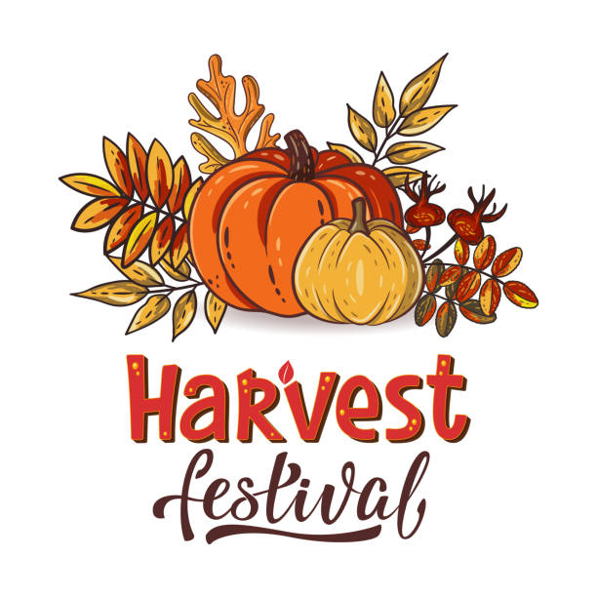

**Knowledge and Understanding**

Taking part in a Harvest Festival Service at St Mary’s Church in Lockington

**Expressive Arts and Design**

Learning to make leaf rubbings and print with natural materials.

**Home Support**

**Support with exploring the book they bring home this week. Phonics pots – Please encourage your child to say the letter name and sound. Put the cards together to make words.**

**Personal, Social and Emotional Development**

Getting to know each other and learning school rules. Looking at people who help us and enjoying ginger bear activities.

**Physical Development**

Riding bikes and scooters.

Testing our fine motor skills using the matching colours of bees game.

**Maths**

Counting and beginning to match objects, pictures and dominoes that are the same.

**Reading and Writing**

Continuing to learn Phase 1 Phonics for Nursery and Phase 2 for reception. Practising learning letter names and sounds and reading words with these sounds in.

**Communication and Language**

Home corner, Mud Kitchen and outside role play areas.