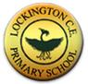
Religious Education Progression Map
Lockington CE VC Primary School
Level Expected at the End of EYFS
The Early Learning Goals that link most closely to the Locally agreed RE syllabus have been taken from Understanding the World.

Understanding the World (People and Communities)  Children know about similarities and differences between themselves and others, and among families, communities and traditions. | Understanding the World (The World)  Children know about similarities and differences in relation to places, objects, materials and living things. They talk about the features of their own immediate environment and how environments might vary from one another.

Key Concepts (Big ideas) in Religious Education
The school follows the locally agreed syllabus for Religious Education. Young people are growing up in a world where there is increasing awareness of the diversity of religious and other worldviews and the impact this diversity can have on individuals and society. Learning about religion and worldviews contributes dynamically to young people’s education by provoking challenging questions about meaning and purpose in life, beliefs about God, issues of right and wrong and what it means to be human.

In RE, young people learn about religion and worldviews in local, national and global contexts, to discover, explore, consider and interpret different responses to life’s big questions. Studying religion and worldviews gives opportunity to develop knowledge and understanding of important aspects of human experience.

The curriculum for RE aims to ensure that all pupils develop religious literacy through:
• Knowing about and understanding a range of religions and worldviews, learning to see these through the disciplines of Theology, Philosophy and Social Sciences
• Expressing ideas and insights about the nature, significance and impact of religion and worldviews through a multidisciplinary approach whilst engaging critically with them
• Gaining and deploying skills taken from the disciplines of Theology, Philosophy and Social Sciences to enhance learning about religions and different worldviews.
Pupils will have a broad, inclusive Religious Education, including studies of religious communities and non-religious worldviews. At all key stages more time will be spent on Christianity than on any other individual religion or worldview ‘to reflect the fact that the religious traditions in Great Britain are in the main Christian’ (Education Act 1988). Principal religions represented in Great Britain are usually regarded as: Buddhism, Islam, Judaism, Sanatana Dharma (Hinduism), Sikhi

Theology

Theology is about believing, asking questions about the concept and nature of god, where beliefs come from and about sources of authority and influence. Pupils will be given opportunities to think about the beliefs and concepts underpinning different faiths, and where those beliefs come from. Consideration will be given to how beliefs may have changed over time, and are similar and different both within a faith and across different faiths. In addition, it considers how these beliefs and concepts provide a framework for understanding life, the universe and everything

Philosophy

Philosophy is about thinking, asking questions about morality and ethics, about the nature of reality and what it means to be human. Using philosophy helps pupils to understand how and why people do certain things and how to live a good life. Through engaging with philosophical questions and reflecting on different responses, pupils will develop their powers to reason, to engage in dialogue and discussion, to deepen understanding about belief, about truth and what is real, about what it means to be good or evil, right or wrong.

Social Sciences

Social sciences are about living, asking questions about the influence of religions and beliefs on individuals, communities, culture and how people live their lives. Using the discipline of Social Sciences to investigate the impact of religious belief and practice in different cultures and societies, pupils will develop an appreciation of the diversity of religious traditions and the way religious beliefs are expressed through, for example, the arts. They will explore personal and community rituals and celebrations in religions and other worldviews and consider the impact of these on individuals and communities.

Intent
At Lockington CE VC Primary School, the Religious Education curriculum plays an integral role in defining the school’s distinctive Christian character. Religious Education plays a significant role in developing children’s spiritual, moral, social and cultural development. The curriculum promotes open mindedness and encourages children to be respectful and understanding citizens who are sensitive to the beliefs of others. Religious Education lessons encourage children to explore, engage and reflect on a wide range of religious beliefs and practices. We believe that it is important for all our pupils to learn from and about religion, so that they can understand the world around them. The aim of Religious Education in our school is to help children to acquire and develop knowledge and understanding of Christianity and the other principal religions represented in Great Britain; to appreciate the way that religious beliefs shape life and behaviour, develop the ability to make reasoned and informed judgements about religious and moral issues and enhance their spiritual, moral, social and cultural development. Religious Education plays an important role, along with all other curriculum areas, particularly PSHCE, in promoting social awareness and understanding in our children. We encourage our pupils to ask questions about the world and to reflect on their own beliefs, values and experiences. We include and promote British values, ensuring that children are aware of their rights and responsibilities as UK citizens. Our curriculum is designed to encourage creativity, imagination, enquiry, debate, discussion and independence.
Implementation
We use the Hull and East Riding of Yorkshire Agreed Syllabus for Religious Education as the basis for our curriculum. At Lockington CE VC Primary School, it has been agreed that having taken into account the requirements and guidelines presented in the Agreed Syllabus, the following religions have been selected for study:
• Christianity
• Islam
• Judaism
• Buddhism

From the syllabus it is required that:-
In the Early Years Foundation Stage the learning outcomes are referenced to Christianity and as appropriate to a range of other beliefs and cultures
• KS1 - Christianity is studied (and one other principal religion in some depth)
• KS2 – Christianity is studied (and two other principal religions in some depth)
As we are a very small school we operate a two year rolling programme for Year 1 and 2 and a four year rolling programme for Years 3, 4, 5 and 6. Reception are taught separately.
We use Understanding Christianity where appropriate to enhance the locally agreed units followed. These can be found on our long term plans.
There are no presumptions made as to the religious backgrounds and beliefs and values of the children and the staff. We value the religious background of all members of the school community and hope that this will encourage individuals to share their own experiences with others freely. All religions and their communities are treated with respect and sensitivity and we value the links, which are, and can be made between home, school, and a faith community. We are very fortunate to have good links with our local church and the children take part in important festivities and services during the year. We acknowledge that each religion studied can contribute to the education of all our pupils. We promote teaching in Religious Education that stresses open enquiry and first-hand experiences wherever possible for both staff and children.
Impact
The children at Lockington CE VC Primary School enjoy learning about other religions and why people choose, or choose not to follow a religion. Through their R.E. learning, the children are able

- to make links between their own lives and those of others in their community and in the wider world
- develop an understanding of other people’s cultures and ways of life
- extend their knowledge and understanding of religions and beliefs
- develop a religious vocabulary and interpret religious symbolism in a variety of forms
- reflect on questions of meaning, offering their own thoughtful and informed insights into religious and secular world-views
- explore ultimate questions of beliefs and values in relation to a range of contemporary issues in an ever-changing society

Religious Education Key Concepts Year Group Mapping
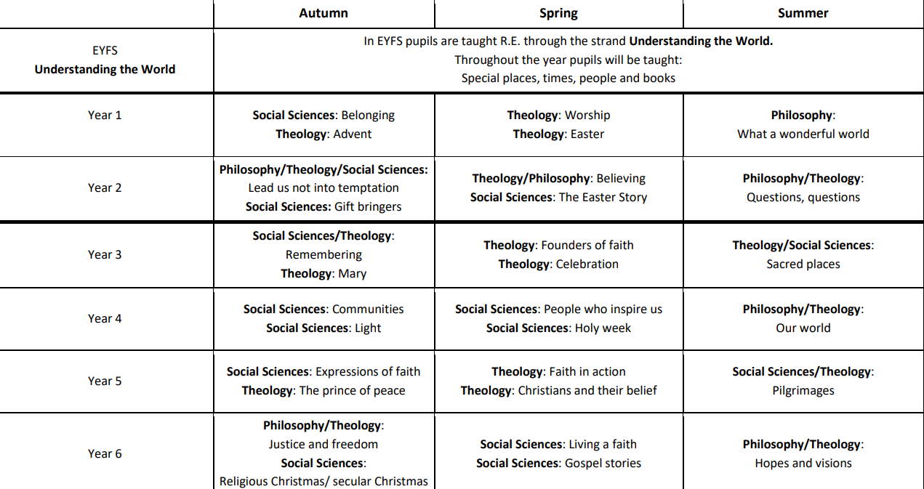

Knowledge and skills sequencing Religious Education
Theology | EYFS | Year 1 | Year 2 | Year 3 | Year 4 | Year 5 | Year 6
 | To explore important religious festivals such as Christmas, Harvest or Diwali. To discuss special events associated with a celebration, and other special days. To express simple meanings associated with religious artefacts. To ask and answer questions about religion and culture. To visit places of worship, showing respect; they learn what happens there. | Worship: To recognise which holy books are special to different religions. | Lead us not into temptation: To respond respectfully to people of different faiths and cultures. Believing: To recall and name key beliefs from different religions. To recognise similarities and differences between the key beliefs of different faiths. To suggest two examples of religious beliefs which lead into action. Questions, questions To describe what different religions believe about God | Remembering: To explain the link between the rituals associated with celebrations and the stories behind them. Founders of faith: To recognise the key events in the lives of some faith founders and the impact they made. To describe and make links between the teachings of faith founders. Sacred places: To recognise what makes a place sacred and suggest reasons why. | Our world: To describe what different religions say about the attributes of God. | Faith in Action: To identify the origins and make connections between the different faith teachings. To give a considered response to the challenges of following a faith. Pilgrimages: To describe and show understanding of actions carried out by a pilgrim. | Justice and Freedom: To discuss barriers to reconciliation and harmony and the power of forgiveness. Hopes and visions: To explain and give examples of how people of different faiths respond to the question ‘Who is god?’
Philosophy | To learn about the differences between right and wrong through stories. | What a wonderful world: To recall Christian/Jewish beliefs about God and creation stories, adding some details. To retell a creation story using relevant vocabulary and say where the story comes from.  To ask their own ‘wondering’ questions about the world Talk about ways of caring for the world | Lead us not into temptation: To respond sensitively to decisions about what’s right and what’s wrong. Questions, questions: To suggest answers to Big Questions from different religious perspectives |  | Our world: To reflect and present ideas about the origin of the universe. To offer reasons why it is important to look after the Earth. |  | Justice and freedom: To explain hopes and dreams for a just community and a just world. Hopes and visions: To debate differing faith views about the purpose of life; compare different possible answers and contrast with a secular view
Social Sciences | To hear stories from religious traditions as a stimulus to reflect on their own feelings and experiences and show an understanding of those of others. To listen to creation stories and talk about the importance of looking after the natural world. To meet, listen to and respond to a range of people from different religious and ethnic groups. To find out what matters to people of faith and no faith. | Belonging: To recall some of the symbols, artefacts and rules associated with belonging to a faith group. To recognise some similarities between faith groups. To talk about what it means to belong and understand the importance of a promise. Worship: To recall the important features of a place of worship and say how they are used. To say why a local place of worship is important for many people. | Lead us not into temptation: To recognise differences and similarities between school rules and religious rules. | Remembering: To compare the ways in which festivals are celebrated in the community and across the world. Sacred places: To discover the milestones in life for different religions and respond to the way they offer a sense of identity and belonging. | Communities: To explain what makes a community. To describe the contribution of a religious group to their community. People who inspire us: To explain what prompts people to commit to an ethical cause. To explain and give reasons why a person of faith devoted themselves to a cause. To give examples of altruistic actions in the community. | Expressions: To identify the importance of symbolism in the expression of beliefs. To describe different forms of worship and spiritual expression and explain where they might take place. Pilgrimages: To identify and explain why people may participate in a pilgrimage. | Living a faith: To explain and give reasons about how personal milestones engender a sense of identity. To discuss and give examples of how participating in rites of passage have an impact on religious communities

Religious Education – Unit mapping with Key Concepts
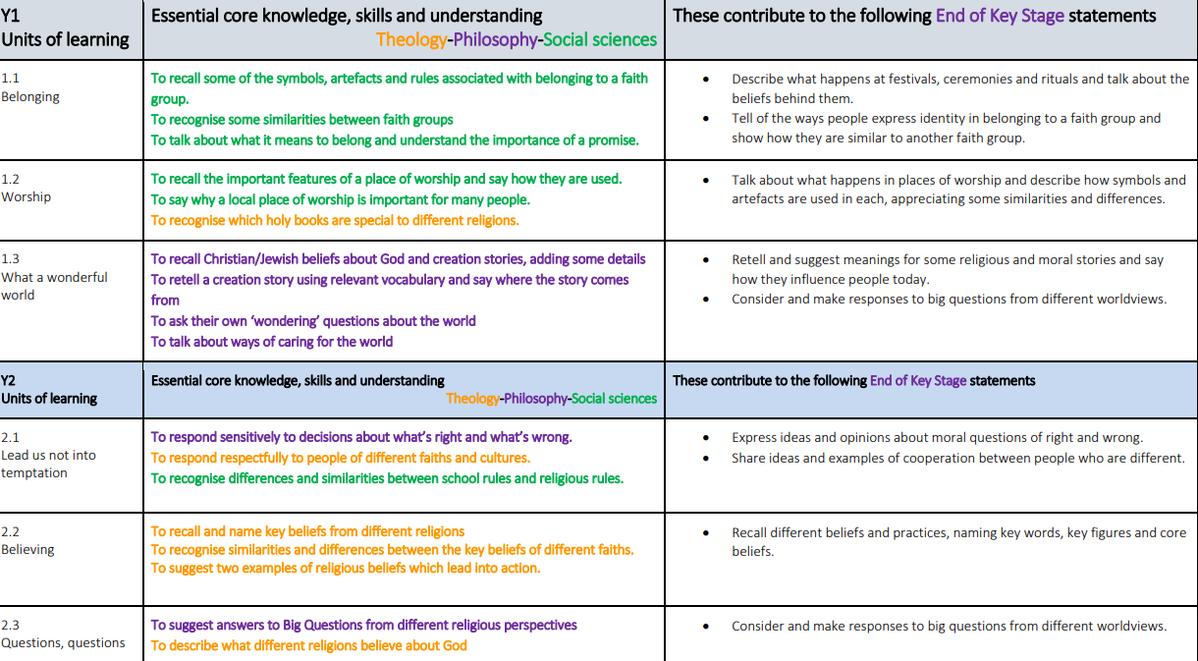

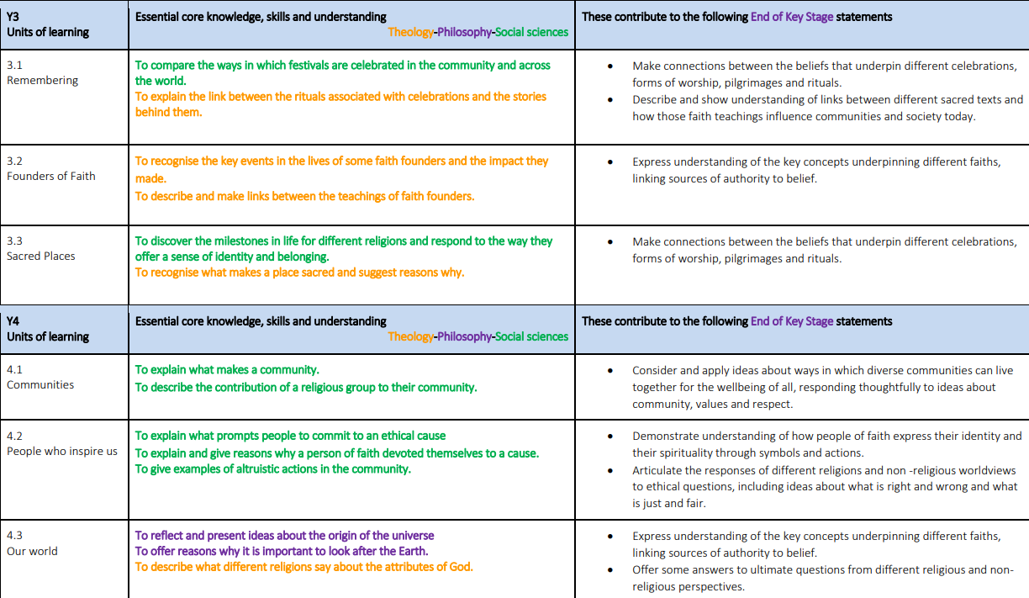

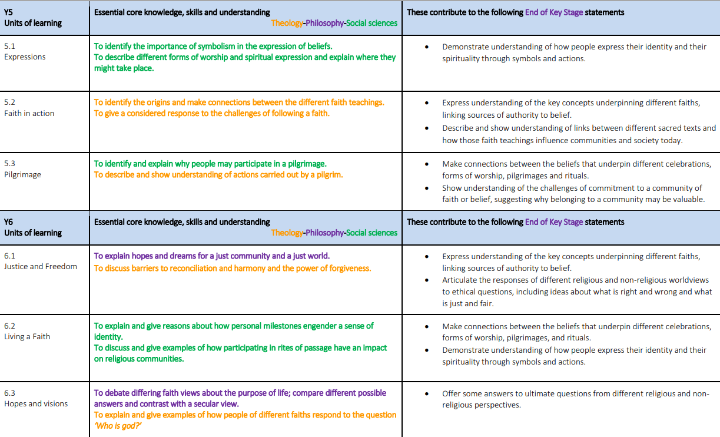

References: East Riding Locally Agreed Syllabus

