Lockington C of E VC
Primary School

Evidencing the Impact of the Primary PE and Sports Premium
2022-2023

(Initial Projection)
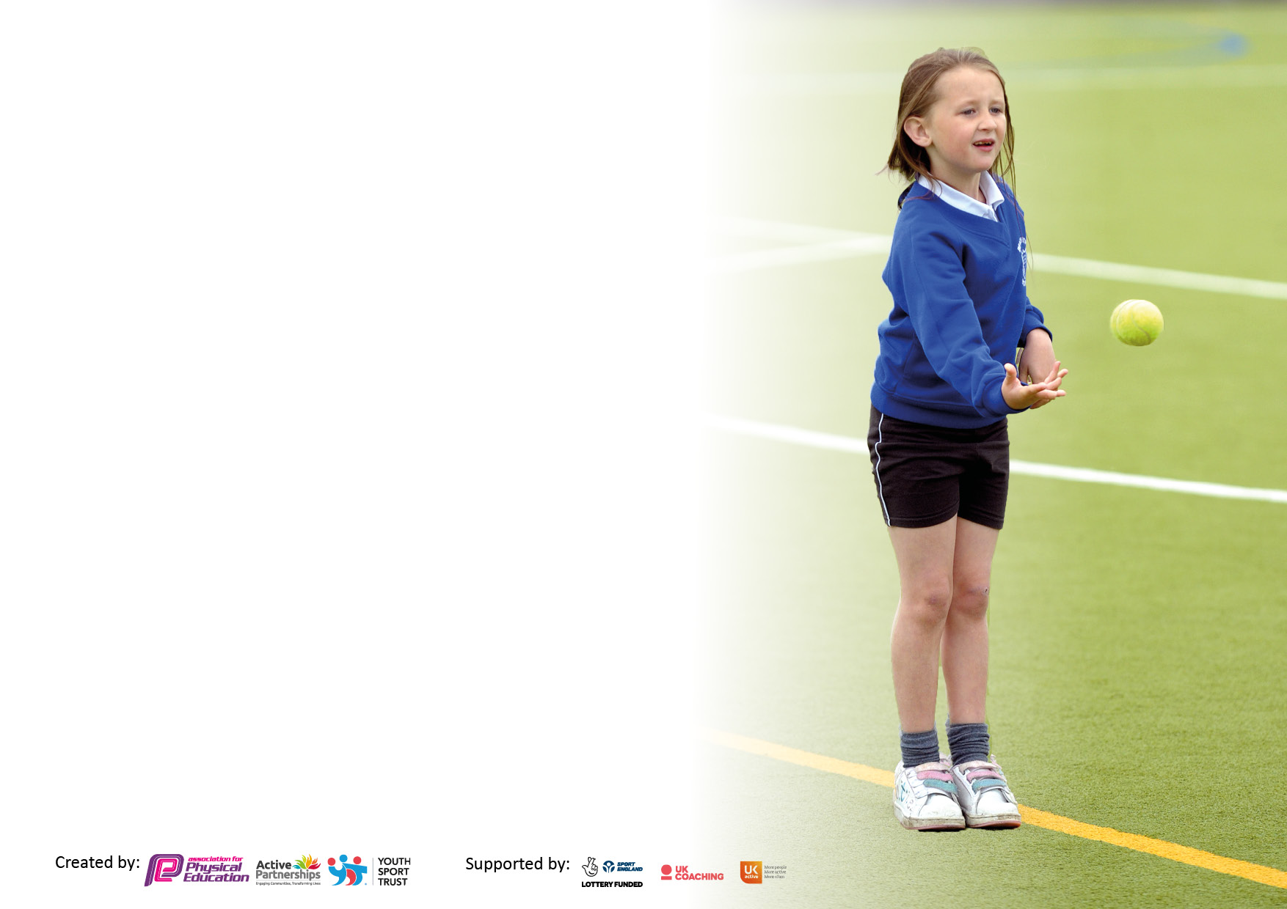

It is important that your grant is used effectively and based on school need. The Education Inspection Framework makes clear there will be a focus on ‘whether leaders and those responsible for governors all understand their respective roles and perform these in a way that enhances the effectiveness of the school’.

Under the Quality of Education Ofsted inspectors consider:
Intent - Curriculum design, coverage and appropriateness
Implementation - Curriculum delivery, Teaching (pedagogy) and Assessment
Impact - Attainment and progress

To assist schools with common transferable language this template has been developed to utilise the same three headings which should make your plans easily transferable between working documents.

Schools must use the funding to make additional and sustainable improvements to the equality of Physical Education, School Sport and Physical Activity (PESSPA) they offer. This means that you should use the Primary PE and sport premium to:

- Develop or add to the PESSPA activities that your school already offer
- Build capacity and capability within the school to ensure that improvements made now will benefit pupils joining the school in future years
- The Primary PE and sport premium should not be used to fund capital spend projects; the school’s budget should fund these.

Please visit gov.uk for the revised DfE guidance including the 5 key indicators across which schools should demonstrate an improvement. This document will help you to review your provision and to report your spend. DfE encourages schools to use this template as an effective way of meeting the reporting requirements of the Primary PE and sport premium.

We recommend you start by reflecting on the impact of current provision and reviewing the previous spend.

PE at Lockington C of E VC Primary School

We believe that physical education is vital to a pupil’s physical, social and emotional health. We understand physical education develops the children’s knowledge, skills and understanding, so that they can perform with increasing competence and confidence in a range of physical activities. We acknowledge the important link between a healthy lifestyle and the ability to learn effectively. We also recognise that school can play a significant role, as part of the larger community, to promote a healthier lifestyle. As a result, we aspire to improve the health of the school community by teaching ways to establish and maintain lifelong physical activity habits. At Lockington, we work hard to unlock the potential of all children by ensuring that our PE curriculum is inclusive to all children. Our aim is for our children to be competent and confident in a wide range of skills through activities and games.

Objectives for allocation of PSSG:
- To resource the EYFS learning environment to be active and child centred, with resources accessible as needed.
- Support the EYFS Curriculum with a particular focus on outdoor learning.
- To provide opportunity, above and beyond the requirements of the National Curriculum, for KS2 pupils to become confident swimmers.
- To ensure KS1 and KS2 have quality resources to enhance the whole curriculum of progressive skills.
- To ensure the safety and longevity of outdoor PE and play equipment to inspire physical activity.
- To allow pupil voice to be a valued part of the sports funding through discussion with the School Games Crew and Play Leaders.

Funding

Total amount carried over from 2021/22 | £2,168
Total amount allocated for 2022/23 | £16,470
Total amount of funding for 2022/23. To be spent and reported on by 31st July 2023. | £18,638

Swimming

Meeting national curriculum requirements for swimming and water safety.

N.B. Complete this section to your best ability. For example you might have practised safe self-rescue techniques on dry land which you can then transfer to the pool when school swimming restarts.
Due to exceptional circumstances priority should be given to ensuring that pupils can perform safe self rescue even if they do not fully meet the first two requirements of the NC programme of study
What percentage of your current Year 6 cohort swim competently, confidently and proficiently over a distance of at least 25 metres?  N.B. Even though your pupils may swim in another year please report on their attainment on leaving primary school at the end of the summer term 2023.  Please see note above | %
What percentage of your current Year 6 cohort use a range of strokes effectively [for example, front crawl, backstroke and breaststroke]?  Please see note above | %
What percentage of your current Year 6 cohort perform safe self-rescue in different water-based situations? | %
Schools can choose to use the Primary PE and sport premium to provide additional provision for swimming but this must be for activity over and above the national curriculum requirements. Have you used it in this way? | Yes  KS2 pupils are given an extra block of 10 swimming lessons biannually to enhance their water safety and confidence.

Action Plan and Budget Tracking
Capture your intended annual spend against the 5 key indicators. Clarify the success criteria and evidence of impact that you intend to measure to evaluate for pupils today and for the future.

Academic Year: 2020/21 | Total fund allocated: | Date Updated:
Key indicator 1: The engagement of all pupils in regular physical activity – Chief Medical Officers guidelines recommend that primary school pupils undertake at least 30 minutes of physical activity a day in school |  |  |  | Percentage of total allocation:
 |  |  |  | %
Intent | Implementation |  | Impact
Your school focus should be clear what you want the pupils to know and be able to do and about  what they need to learn and to  consolidate through practice: | Make sure your actions to achieve are linked to your intentions: | Funding allocated: | Evidence of impact: what do pupils now know and what can they now do? What has changed? | Sustainability and suggested next steps:
To maximise the resources on offer from the SSP.  To support provision of high quality, inter and intra school sport and sports development.  To provide links to local sports clubs.  To encourage targeted Y3 pupils (identified as having been impacted through Covid restrictions) to widen their access to sporting activities.  To introduce a new sporting activities for all pupils across both key stages.  To promote the importance of Active 30 to the pupils through new signage.  To provide resources and support for KS1 teachers in order to deliver to a large younger cohort.  To ensure access to equipment is safe and compliant with current coronavirus guidelines.  To ensure a safe sustainable environment to give value and importance to sporting life in school. | Annual membership of the SSP.  SSP events to be attended throughout the year to offer a variety of experiences across KS2.  Consultation with SSP.  Places available (pro-rata of Y3 numbers) to attend an activity day during the February half term.  Competitions attended.  Angel Sanderson in school 1/2/22 to promote Active 30.  Owen Denovan in to work with KS1.  Refurbishment of the current adventure trail & outdoor equipment.  Inspection and annual checks of PE and outdoor sports equipment  School field markings and preparation for use. | £3,500  £2,000  £350 | Sporting events attended thus far:  - Cross country  - Table tennis  - Zoneball  62% of KS2 pupils had taken part in inter-school competitive events in the Autumn term. This is more than any previous year.  Trim trail and pirate ship continue to be the focal point of pupils’ play time. | To continue to develop and further improve engagement by:  - Accessing any further CPD available through the SSP  - Reviewing the club registers in order to identify less active pupils quickly  - Carry out a pupil questionnaire to engage their views  - Enlist in the help of the Young Play Leaders to maximise the use of the outdoor activity stations
Key indicator 2: The profile of PESSPA being raised across the school as a tool for whole school improvement |  |  |  | Percentage of total allocation:
 |  |  |  | %
Intent | Implementation |  | Impact
Your school focus should be clear what you want the pupils to know and be able to do and about  what they need to learn and to  consolidate through practice: | Make sure your actions to achieve are linked to your intentions: | Funding allocated: | Evidence of impact: what do pupils now know and what can they now do? What has changed? | Sustainability and suggested next steps:
To recognise hard work, commitment, performance and leadership in PE and Sport.  To support in the training of young people to become mini medics in school to support the PSHE curriculum.  To continue to raise the profile of PE throughout the school with a focus on the youngest pupils accessing outdoor play at all times.  To enhance sports provision, in-house CPD, and training to equip a team of young leaders with the skills to engage and inspire their peers.  To ensure that the nursery and EYFS learning environment clearly organised, well maintained and child centred, with resources accessible as needed.  To replace worn and damaged equipment.  To introduce new sporting opportunities. | The opportunity to nominate individuals and teams for our Annual SSP Sports Awards  CPD attended in First Aid Basic teaching for KS2 pupils. Plans to be incorporated within LTP.  Additional staffing for KS1 to ensure active learning (alongside class teacher).  Provision of Sports Specialist to enhance sports provision - N Trueman.  Resources: large scale play and construction toys to develop active learning in EYFS:  Balance Track  Fitness Dice  Throw & Catch pack  Balance Beam  Activity Spots  Accessible Store  Sequence Spots  School Resources to enhance curriculum implementation:  Tennis balls  Hockey Sticks | (within £3,500)  £500  £2,460  £28.50  £13.20  £108.68  £58.18  £21.80  £187.65  £10.60  £55.00  £78.00 | The nursery and EYFS pupils are thriving in a culture of outdoor education. Planning between nursey and KS1 staff ensure high priority with new equipment being ordered.  Sports Leader has continued to provide free sports clubs after school.  (62% of KS2 attend)  New School Games Crew have been elected and regularly lead parts of sessions and activity days.

Key indicator 3: Increased confidence, knowledge and skills of all staff in teaching PE and sport |  |  |  | Percentage of total allocation:
 |  |  |  | %
Intent | Implementation |  | Impact
Your school focus should be clear | Make sure your actions to | Funding | Evidence of impact: what do | Sustainability and suggested
what you want the pupils to know | achieve are linked to your | allocated: | pupils now know and what | next steps:
and be able to do and about | intentions: |  | can they now do? What has
what they need to learn and to |  |  | changed?
consolidate through practice:
To support KS1 in delivering across a wide age with a high percentage of EYFS.  To cover to allow P.E. coordinator to access SSP meetings and other CPD in order to raise the profile of PE and ensure up to date and relevant issues are incorporated into future plans.  To release staff for the purpose of in-house CPD training to share new initiatives and support colleagues and share ideas with link governor. | Tailored support from OD to ensure the teaching in KS1 can be differentiated confidently with the new, larger EYFS cohort.  Annual PE Conference attended.  Subject leader time to update school policies and progression maps.  Play Leaders and SGC training and development to be undertaken.  New PE link Governor to be brought up to date with documentation and given opportunity to work alongside PE Lead. | (within £3,500)  £280  £140 | Skills Progression in place after discussion with staff. Children are becoming aware of next steps and developing skills.  PE link Governor has now become an integral part of the swimming sessions after an initial meeting. LD now supports to improve the staff/pupil ratio and has begun to teach one pupil 1:1 under the guidance of the leisure centre staff. The pupil involved has already gained in confidence. | Regular consultation with KS1 staff to plan and implement further CPD.  Potential new staff to train in the school’s commitment to PE and KS1 outdoor provision.
Key indicator 4: Broader experience of a range of sports and activities offered to all pupils |  |  |  | Percentage of total allocation:
Intent | Implementation |  | Impact
Your school focus should be clear | Make sure your actions to | Funding | Evidence of impact: what do | Sustainability and suggested
what you want the pupils to know | achieve are linked to your | allocated: | pupils now know and what | next steps:
and be able to do and about | intentions: |  | can they now do? What has
what they need to learn and to |  |  | changed?
consolidate through practice:
To provide extra swimming coaching by staff at Beverley Leisure Centre and transport for this.  To deliver lunchtime clubs to all age groups without any barriers caused by extra-curricular restrictions (eg transport, parental commitments etc).  To extend the provision of extra-curricular clubs.  To introduce different sports enhance access to exercise opportunities and inspire out of school activity. | Extra swimming sessions (above and beyond the NC requirements) thus ensuring that each KS2 pupil has twice as much experience in both swimming instruction and water safety skills. This is particularly in light of the restrictions imposed by Covid which meant many younger pupils missed private swimming tuition.  To employ First Steps Sports to provide additional support to ensure that every child can access extra-curricular clubs to develop a positive and sustainable attitude to exercise.  Provision of PE staff to deliver differing sporting skills and enhance PE provision - N McWatt. (tbc) | £900  £2,000  £1,800  £1,500  (tbc) | Children are still presently swimming and will receive data in due course.  First Steps after school club is regularly attended.  The lunchtime club ensures that 100% of pupils are now accessing extra-curricular PE.

Key indicator 5: Increased participation in competitive sport |  |  |  | Percentage of total allocation:
 |  |  |  | %
Intent | Implementation |  | Impact
Your school focus should be clear | Make sure your actions to | Funding | Evidence of impact: what do | Sustainability and suggested
what you want the pupils to know | achieve are linked to your | allocated: | pupils now know and what | next steps:
and be able to do and about | intentions: |  | can they now do? What has
what they need to learn and to |  |  | changed?
consolidate through practice:
To participate in events locally, through the SSP and within the school. | Intra sports held during school sessions to allow all children to participate.  Events chosen to reflect competition and involvement in new sports.  Regular consultation with pupils to encourage all to be involved in a competition during the school year.  School Games Crew deployed to organise and officiate intra-school competitions to allow for pupil voice and ownership.  School field markings and preparation for use particularly for School Games Day. | (within £3,500)  £200 | SSP events attended (both inter and intra school).  This has ensured 100% of KS2 pupils have experienced competitive sport.  School Games Crew have successfully organised their own intra school events which has given them confidence as umpires, referees etc | To continue to access the SSP competition provision.  To follow-up on the request made for enjoyment and participation events for KS1 to set the foundations of inter school PE.

Signed off by
Head Teacher:
Date:
Subject Leader:
Date:
Governor:
Date:

